**2. Create a *tidy* spreadsheet/table listing the names of Danish monarchs with their birth- and death-date and start and end of their reign. They should be sortable by year of birth. Suitable source website is for example**[**here**](https://kongehuset.dk/monarkiet-i-danmark/kongerakken)**, but you can also use another source, provided you reference it. (Collaboration is welcome. Remember to attach this spreadsheet to Brightspace submission)**

I first manually sort the data into an Excel sheet like so:

To get the data sorted, so that it is sorted by birth (fødsel), I use the speadsheet in Openrefine, use the dropdown menu at “Fødsel” to then choice “Sort…”, I can then set the cell value to numbers and choice the “smallest first” box.

Then I the document is sorted by

*The sorting menu*

2. Does OpenRefine alter the raw data during sorting and filtering?

It does not alter the raw data, making the program good

3. Fix the[interviews dataset](https://ndownloader.figshare.com/files/11502815) in OpenRefine enough to answer this question: "Which two months are reported as the most water-deprived/driest by the interviewed farmer households?"

value.replace("[","").replace("]","").replace("'","").replace(" ","").replace(";"," ").split(" ")

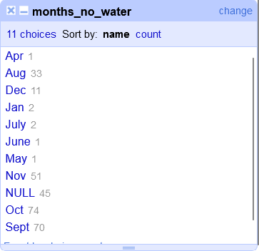

*Example of how the end result looked in Openrefine*